Faking Acceleration Due to Gravity

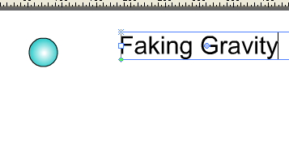 | 1. Draw a ball (Hold SHIFT button)
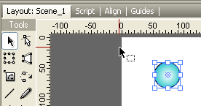 | 2. Select ball with arrow tool
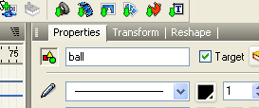 | 3a. Name the ball in the Properties Panel (upper left)  3b. Select the target option

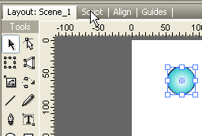 | 4. Select the Script Panel (left)
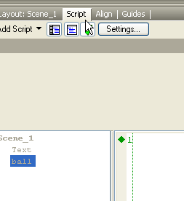
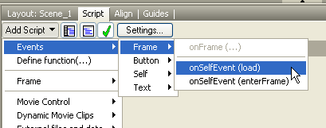 | We are now going to create a variable called Vy that loads only when the animation starts  5. Select  a) Add Script  b) Events  c) Frame  d) onSelfEvent (load)

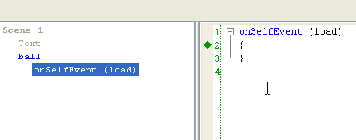 | Your program should look like this. Variable will be defined within the brackets.  Make sure your cursor is within the brackets
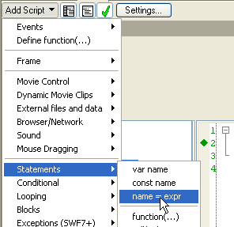 | We are now going to now create the variable Vy  5. Select  a) Add Script  b) Statements  c) Name=expr
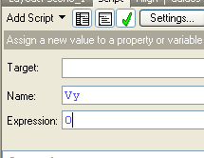 | 6. Make Vy = 0

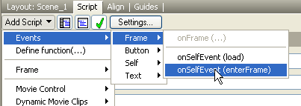 | We are now going to create an equation that executes on every frame  5. Select  a) Add Script  b) Events  c) Frame  d) onSelfEvent (enterFrame)
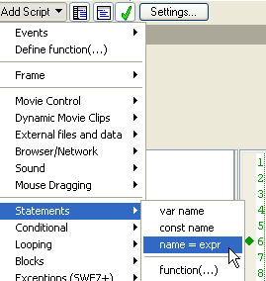 | 5. Select  a) Add Script  b) Statements  c) Name=expr
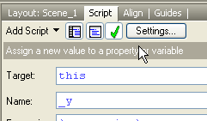 | We are going to create an equation that adds Vy to the balls vertical position on every frame  6. Fill out the form as shown on the left

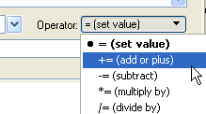 | 7. Change the Operator to +=  (this means add)
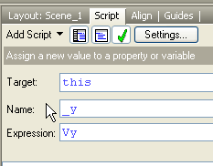 | 8. Give Expression the value Vy
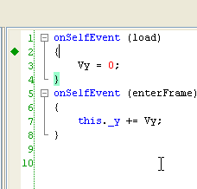 | Make sure your cursor is within the brackets in the load SelfEvent

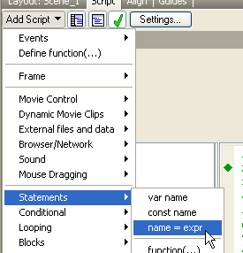 | 9. Select  a) Add Script  b) Statements  c) Name=expr
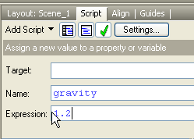 | Create a variable called gravity that loads when the animation loads and is assigned the value of 1.2  10. Fill out the form as shown in the illustration on the left
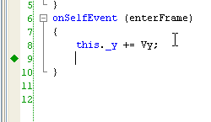 | 11. Place your cursor inside the enterFrame SelfEvent after the code this._y += Vy;

12. Select

a) Add Script
b) Statements
c) Name=expr
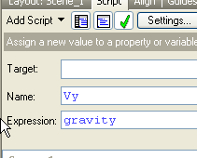 | 13. Fill out the form as shown in the illustration on the left
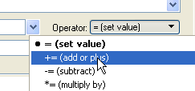 | 14. Change the Operator to += (see left)  This will make Vy increase by gravity (1.2) on every frame

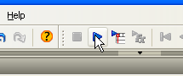 | 15. Play
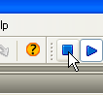 | 16. Stop

